Arrange-Act-Assert (AAA) Pattern, Test Fixtures, Setup and Teardown Methods in Junit:
- Create a project with name “Junit Exercise4”
- Now create a java class in srcmain with name Calculator.java.
- Now create a class in srctestjava with name CalculatorTest.
- Type the code to test using the test classes.
Output when a single test case of addition is given
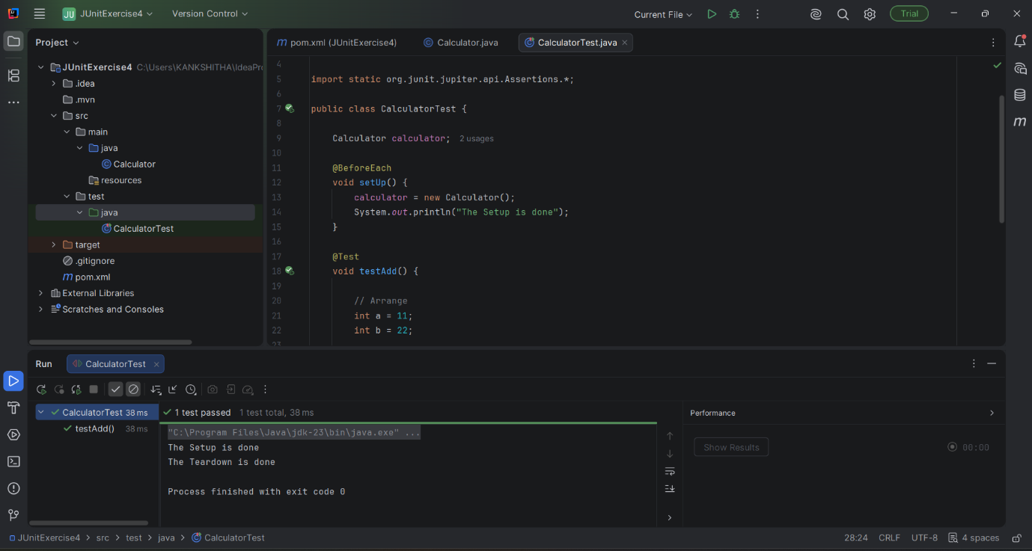
Output when two test cases are tested with addition and subtraction
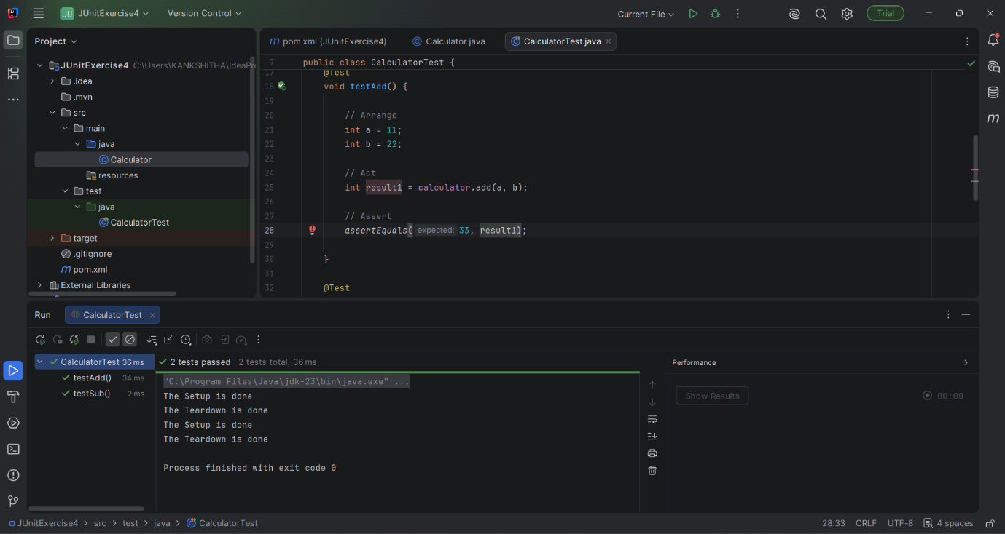

@TestThis tells that the below code is a test case
@BeforeEachAnnotates that this will be executed before each test case
@AfterEachAnnotates that this will be executed after each test case
AAA Pattern
AArrange: This is where we prepare the data.
AAct: Here the method is called to perform the function.
AAssert: Here the results will be checked.

